Gift Aid Donation Form
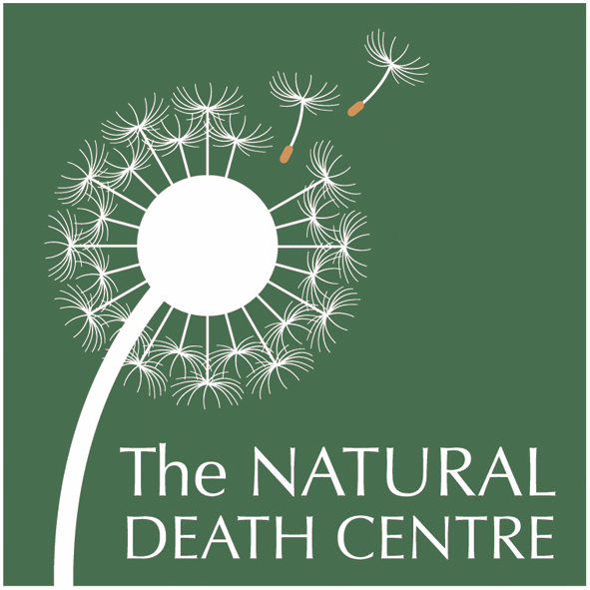

Using Gift Aid means that we get an extra 25% from the Inland Revenue, helping your donation go further.
This means that £100 can be turned into £125, just fill out the form below. Imagine what a difference that could make, and there is no extra cost to you!
If you have any questions about Gift Aid, please contact us and we will be happy to help

GIFT AID DECLARATION
Details of donor:
Title …........…. Forename(s) ………………………..........................……… Surname……………………………..…………………………….......…………………...…
Address.……………………………………………………….…………………………………….…………………………………………
……………..…..….………………..…………………………………………………………………………….………………………………
……………………………………………...………………………………………………………………………………………………………
Post Code ............................. Telephone Number…………....……………………………………………………
Email: ......………………………………………………………………………………………………………………………………………

I want the charity to treat
*all donations I have made since 6 April 2000 and all donations I make from the date of this declaration until I notify you otherwise as Gift Aid donations.
Signature ……………………………………………………….. Date - - /- - / - - - -

Please make cheques payable to:
The Natural Death Centre
Dealing with Death Naturally

Registered Charity No 1091396

Notes:
You must pay an amount of income tax and/or capital gains tax at least equal to the tax that the charity reclaims on your donations in the tax year.
You can cancel this declaration at any time by notifying the charity.
If in the future your circumstances change and you no longer pay tax on your income and capital gains equal to the tax that the charity reclaims, you can cancel your declaration (see note 1).
If you pay tax at the higher rate you can claim further tax relief in your Self- Assessment tax return.
If you are unsure whether your donations qualify for Gift Aid tax relief, ask the charity. Or ask your local tax office for leaflet IR 65.
Please notify the charity if you change your name or address:

The Natural Death Centre
In The Hill House
Watley Lane
Twyford
Winchester
Hampshire
SO32 1FR

01962 712 690
contact@naturaldeath.org.uk
www.naturaldeath.org.uk

Thank you for your kind support

- Please tick here If you would like to receive the free Natural Death Centre Newsletter (via email)

